Shark liver oil protects the chromosome and sperm of mice against the cytotoxicity of Taxotere.
Mohamed Zowail, Marwa M. Refaat, Mohamed H. Awwad, Eman Khater, and Ebtesam H. O. Nafie.
Abstract:-
The natural ether-lipids 1-O-alkylglycerols from shark liver oil (SLO) supposed to improve sperm motility and fertility. Also, they reduce the side effects of radiotherapy, inhibit tumor growth and both stimulate and modulate immune responses. This study aimed to show the protective effect of SLO against the side effects of Taxotere on mice chromosomes and sperms.
Thirty adult male mice weight (23-27gm) were used in this study. The animals were housed in plastic cages at the same temperature and humidity conditions. They were divided into 6 groups each one contains 5 male mice that were used for studying chromosomal abnormalities and sperm head and tail morphology by using classical cytogenetic methods. The administered doses of Taxotere were 8 mg/kg. Mice injected SLO at a dose of (10 mg/kg/day).

Results showed that Taxotere caused structural and numerical chromosomal aberration including deletion, centromeric attenuation, ring, monoploidy, and polyploid. It also caused sperm head and tail abnormalities such as without hook, amorphous, hummer head and sperm with a coiled tail. Our results proved the efficiency of SLO to protect mice chromosomes and sperms against the cytotoxic effect of Taxotere.

Introduction:-
Taxotere (Docetaxel) is a second-generation taxane extracted from the needles of the European yew tree (Noguchi, 2006). Taxotere is an agent with significant clinical antitumor activity like ovarian, breast, and prostate cancers. Its activity has also been seen in a number of tumors that are generally refractory to other chemotherapeutic agents, such as lung, head and neck, bladder, and esophageal cancers, as well as in metastatic breast and lung cancers (Hotchkiss et al., 2002).
Each vial of Taxotere Injection Concentrate is a sterile, non-pyrogenic, pale yellow to the brownish-yellow solution at 20 mg/mL concentration. Each mL of 1-vial Taxotere contains 20 mg Docetaxel in 0.54 grams polysorbate 80 and 0.395 grams dehydrated alcohol solution (Evaluation, 2015).
Taxotere binds to β-tubulin subunits that prevent microtubules depolymerizing causing disruption in mitotic spindle formation results in inhibition of cell division and lead to cell death (Hassett et al., 2001). An additional mechanism of action of Taxotere may be phosphorylation of members of the BCL-2family of proteins (Kraus et al., 2003). Taxotere has been shown to inhibit angiogenesis both in vitro and in vivo (Herbst & Khuri, 2003).
Shark liver oil (SLO) is obtained from the fresh and livers of various species of sharks. SLO is rich in alkylglycerols, which are naturally found in mother's milk and in the bone marrow. It also contains pristine, squalene, vitamins A, vitamin D, omega-3 fatty acids, triglycerides, glycerol ethers, and fatty alcohols (Gupta et al., 2015).
SLO reduces the side effects of radiotherapy, inhibits tumor growth and both stimulate and modulate immune responses (Mitre et al., 2004). Many different mechanisms are suggested for these multiple activities, resulting from the incorporation of alkyl-Gro into membrane phospholipids, and lipid signaling interactions (Deniau et al., 2010).
Material and methods:-
Experimental design:-
Thirty adult male mice weight (23-27gm) that were used in this study. The animals were housed in cages at the same conditions from temperature and humidity. The experimental animals were categorized into 6 groups, each included 5 animals. The animal received various treatments for different periods as shown in Table 1.
Table(1):-The experimental design:-
Group treatment:-
Group (1):- Control group- 5 mice with no injection.
Group (2):- Taxotere group- 5 mice have injected IP with Taxotere three times per week for two weeks.
Group (3):- Natural product group-5 mice have injected IP with shark liver oil every day for two weeks.
Group (4):- 5 mice were injected with Taxotere for two weeks then with shark liver oil also for two weeks. (Taxotere+SLO).
Group (5):- 5 mice were injected with shark liver oil for two weeks then with Taxotere also for two weeks. (SLO+Taxotere).
Group (6):- 5 mice were injected with Taxotere and shark liver oil at the same time. (Taxotere&SLO).

Taxotere (Docetaxel):-
The mice have injected IP with Taxotere. The administered doses of Taxotere were 8 mg/kg by (Yonemura et al., 2004)

Shark live oil (SLO):-
We get SLO capsule from El – Ezabi pharmacy. Each contains 100% pure natural arctic extracted from the liver of the Shark. Mice injected a dose of SLO (10 mg/kg/day) (Hajimoradi et al 2009).

- chromosomal preparation experiment:-

After the last day of injection animals were sacrificed. Bone marrow cells collected from mice femurs for mitotic index and chromosomal aberration studies. According to (Zowail, et al., 2012)
- Sperm morphology assay:-
The epididymis of each mouse was taken and minced carefully with scissors in saline solution for obtaining sperms then the solution was filtrated to get rid of large debris of tissues. The solution with sperms was stained by 1% eosin (Mukhe, et al., 1988) then were spread on clean sild and were examined under a light microscope.1000 sperm per mice were examined for head and tail morphology abnormalities detection.
Statistical analysis:-
It was performed by using SPSS software (version 14) and by using a T-test. When P value less than 0.05 it was considered as a significant value also mean and standard error was calculated. (Green B S, 2009)

Results:-
There are two types of chromosomal aberration; structural and numerical chromosomal aberration and both of them were detected in 50 metaphases well-spread fields per mice. The normal sample in (figure 1a) shows that mice contain 20 pair of chromosomes. Chromsomal abnormalities represented as deletion (figure 1b), centromeric attenuation(figure 1c), ring (figure 1d), momoploid (figure 1e), polyploidy (figure 1f).
The mean values of total chromosomal aberration in mice were represented in table (2) and figure (2). These data show that there was no significant difference between the control group and the Shark liver oil (SLO) treated group as the mean values were ((5.4$±2.1)$and (7.8$±2.31)$). There was also a significant increase in the mean values of Taxotere treated group over the mean value of the control group and SLO only treated group where the mean values of them were ((174.6$±9.63)$vs(5.4$±2.1)$and (7.8$±2.31)$).Using SLO as a treatment after Taxotere dose injection showing a significant decrease in total chromosomal aberration comparing with taxotere only treated group with mean values were ((84.6$±4.41)$vs (174.6$±9.63)$). Also, the protective effect of SLO injection before Taxotere treatment showing a significant decrease in total chromosomal aberration comparing with taxotere only treated group as the mean values were (136.4$±6.61)$vs (174.6$±9.63)$). The injection of Taxotere at the same time with Slo also showing a significant decrease in total chromosomal aberration comparing with taxotere only treated group as the mean values were ((102.6$±6.18)$vs (174.6$±9.63)$). All these results show that using Slo as a treatment after Taxotere treatment was more effcient than the protective effect of Slo and than the injection of both SLO and Taxotere at the same time in decreasing the total chromosomal abberation caused by Taxotere treatment.
a)  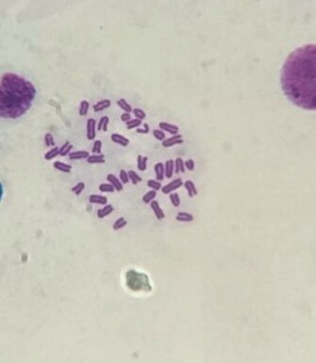 | b)  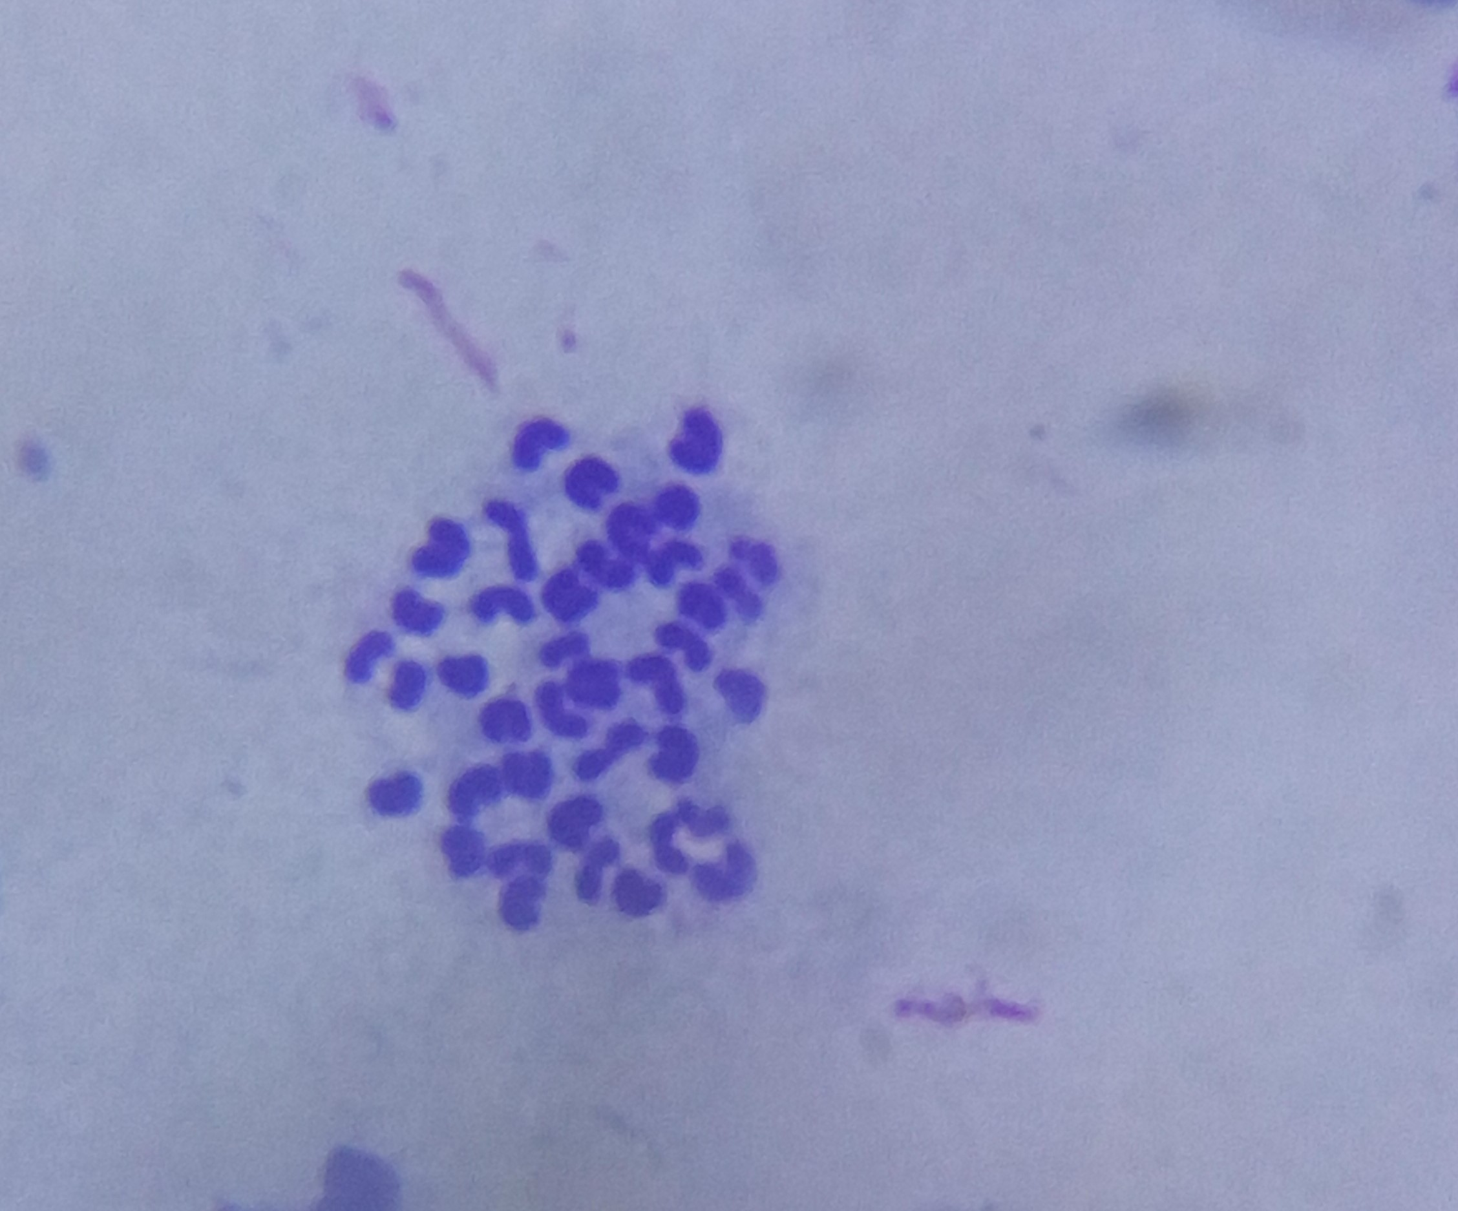 | c)  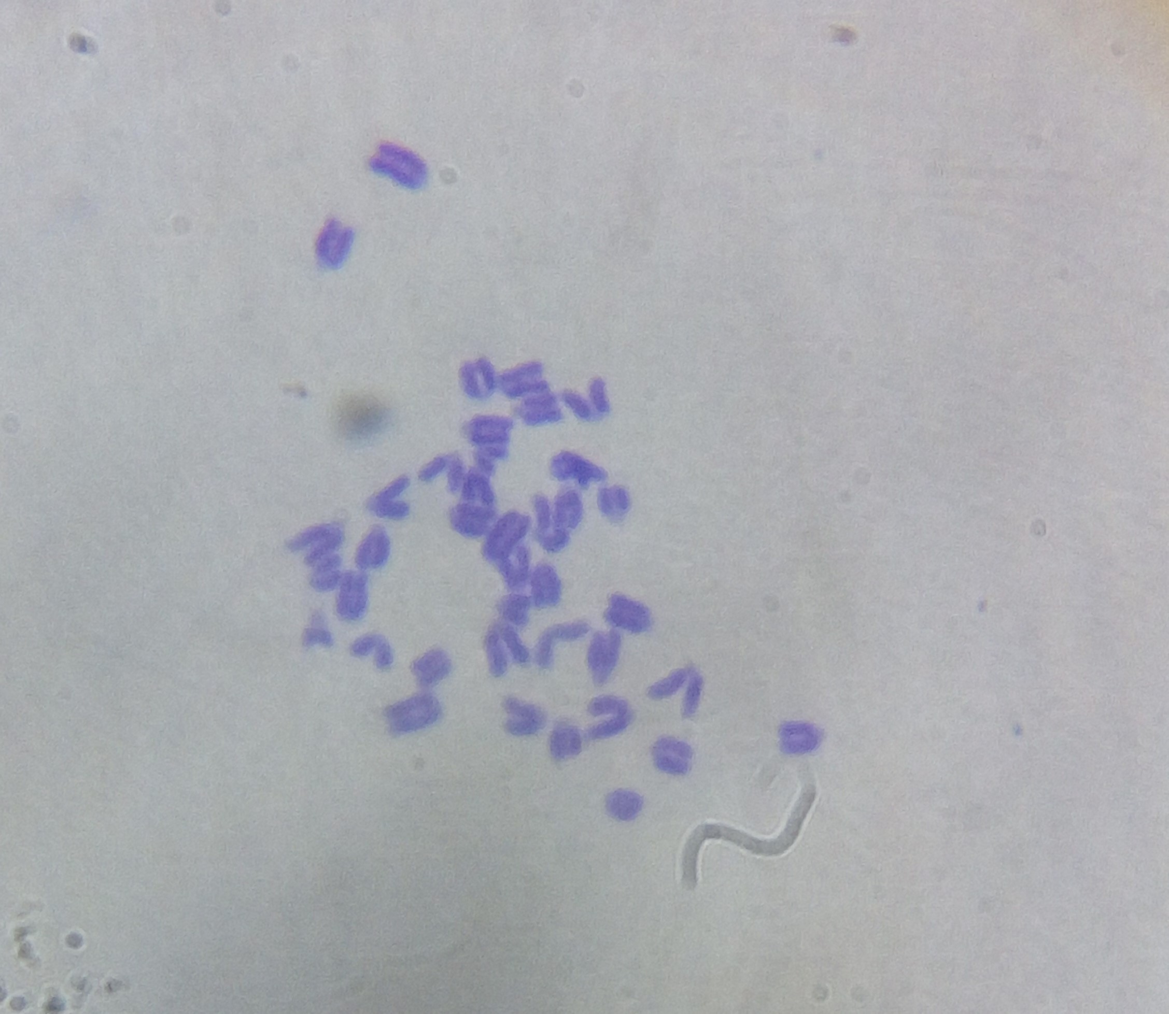
d)  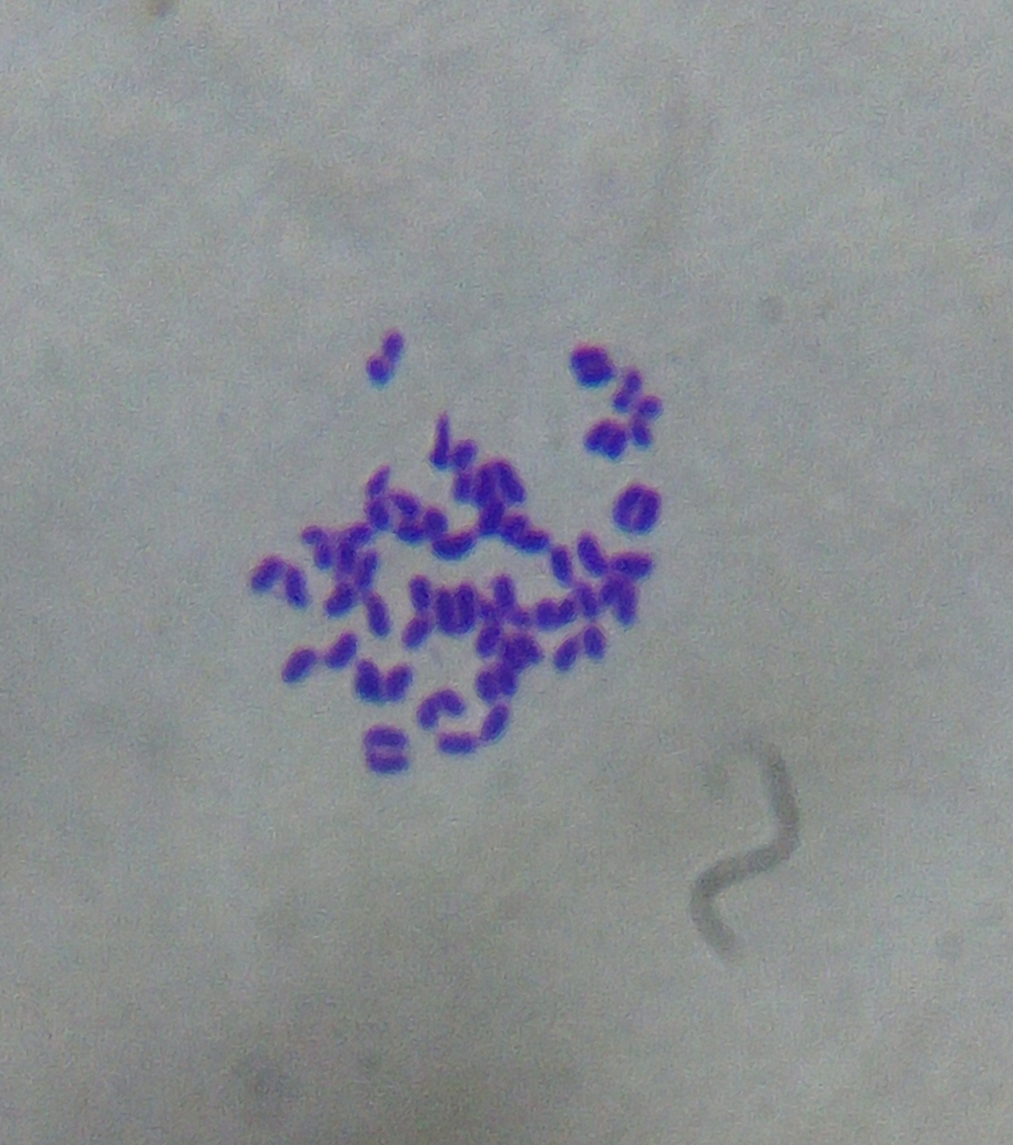 | e) | f)  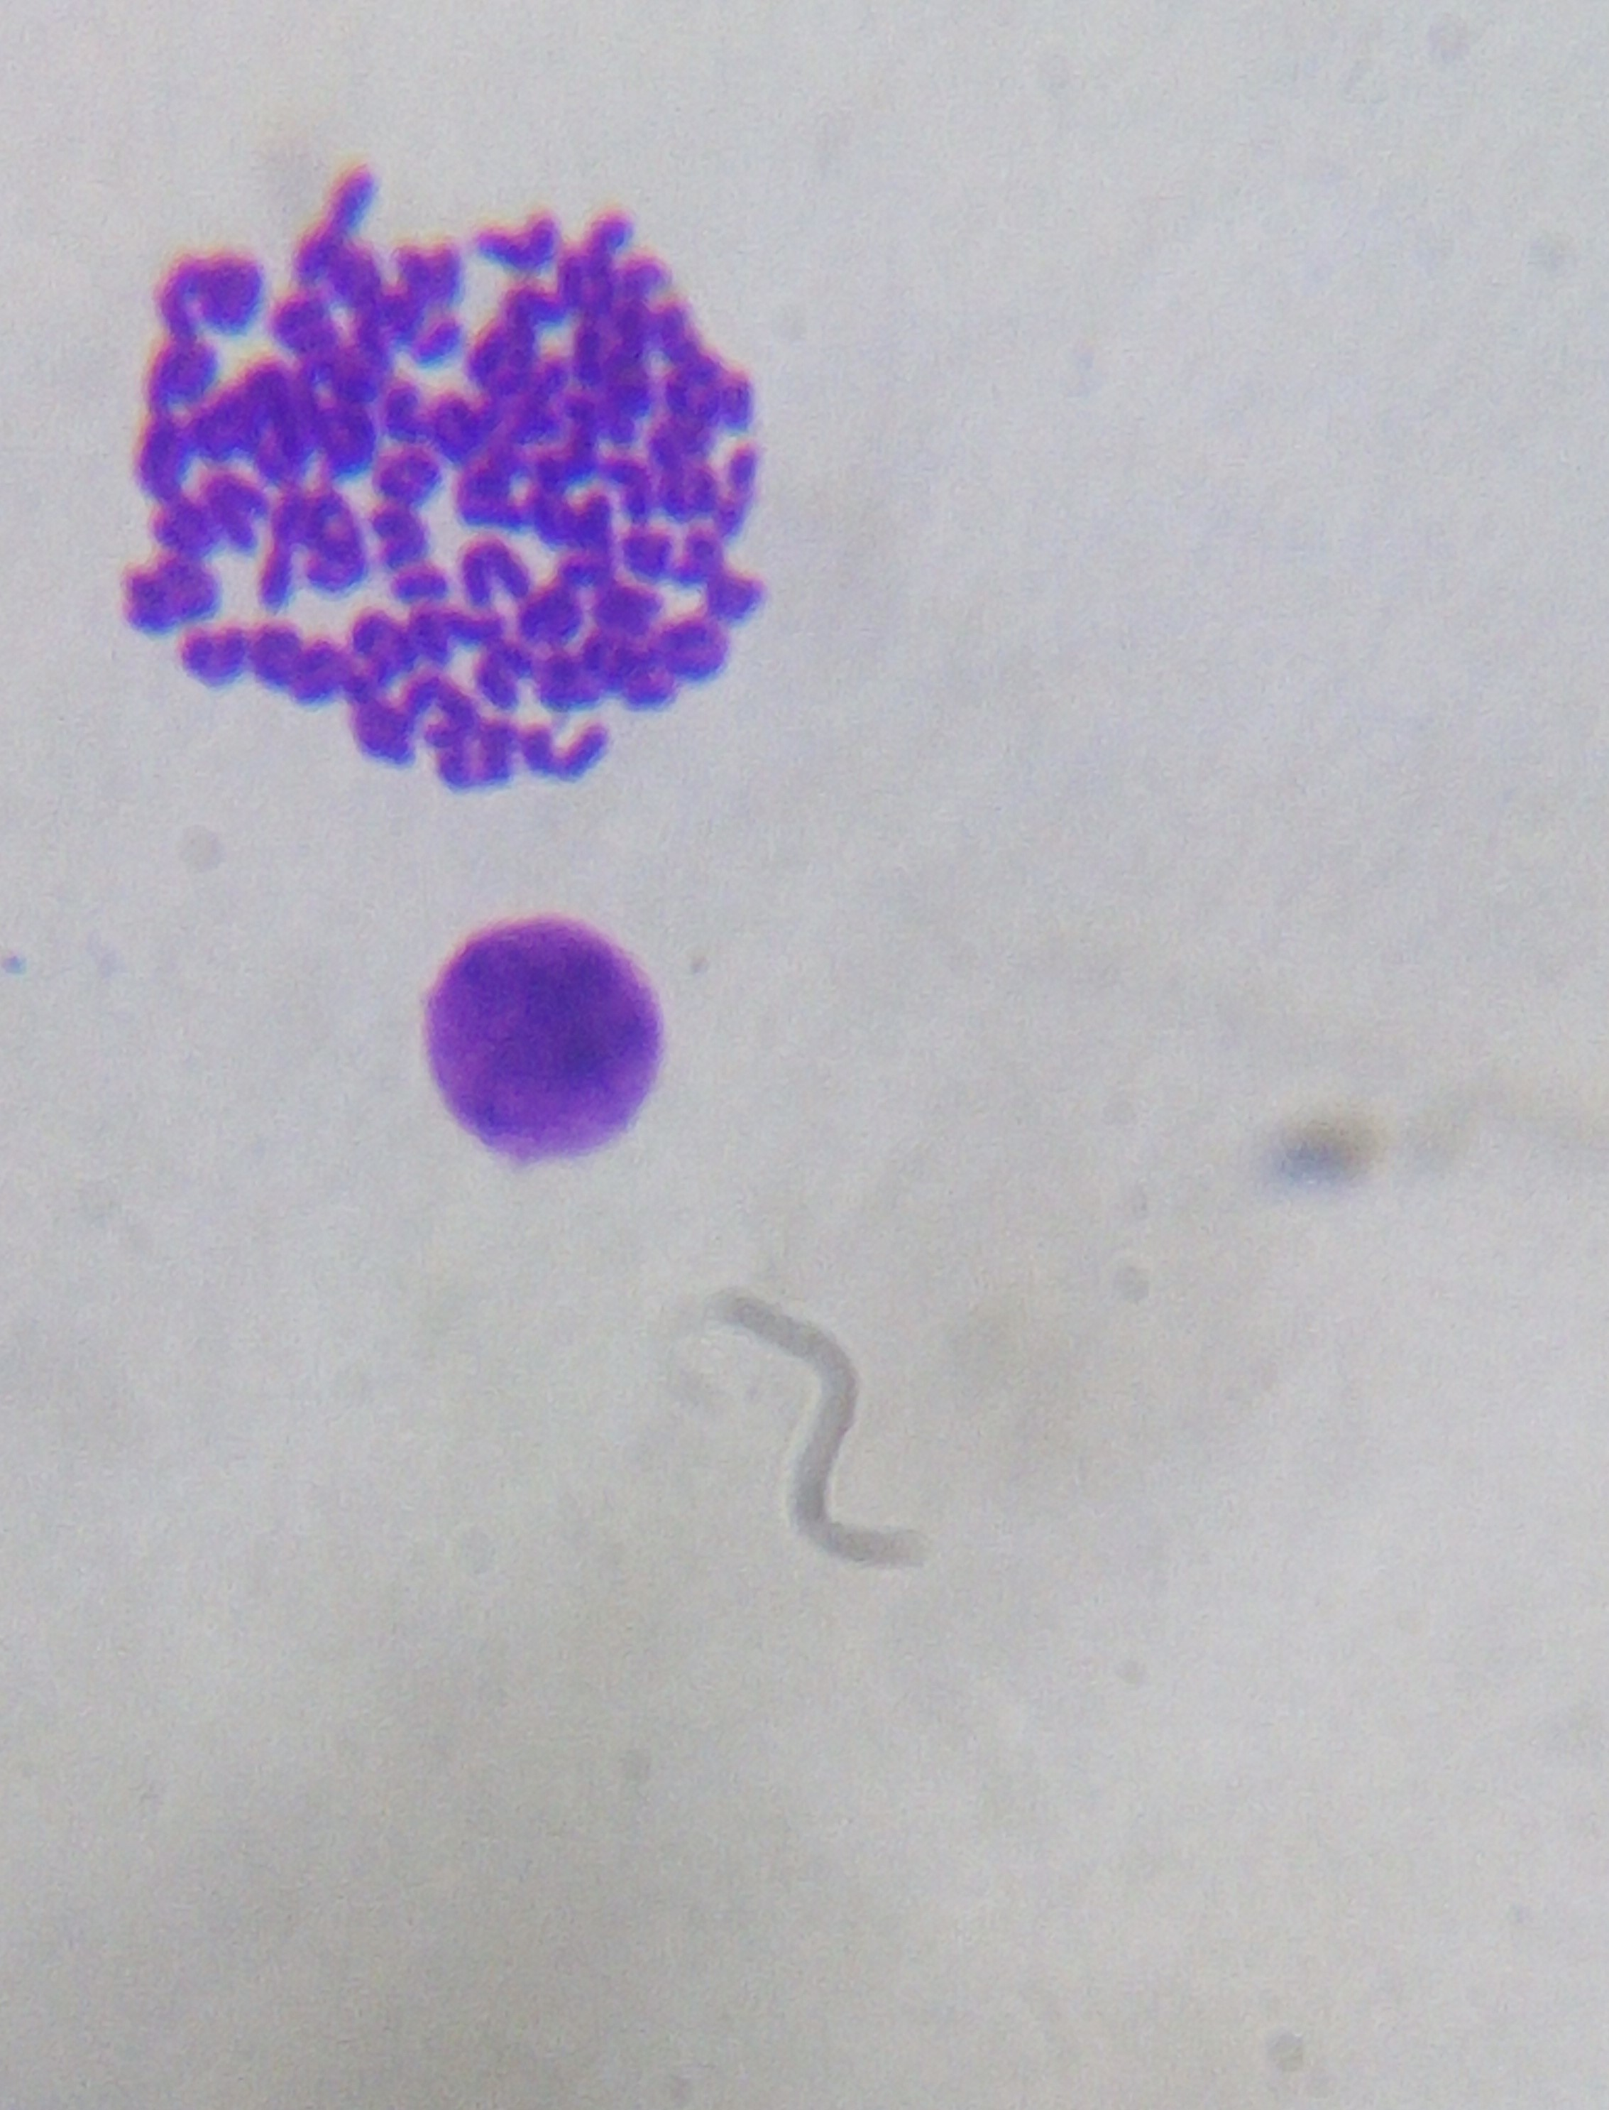
Figure 1:- A) normal chromosome. B) Deletion. C) centromeric attenuation. D) ring. E) monoploid. F) polyploidy.

Table (2):- The average structural and numerical chromosomal aberration in mice bone marrow cells.
Total  aberrations | Polyploidy | Monosomy | Ring | Centromeric attenuation | Deletion | Groups
(5.4$±2.1)$ | (0$±0)$^{cef} | (1.8$±0.37)$^{cef} | (0.4$±0.24)$^{ce} | (1.6$±0.51)$^{cdef} | ^{cdef} (1.2$±0.58)$ | Controlª
(7.8$±2.31)$ | (0$±0)$^{cef} | (1.6$±0.68)$^{cdef} | (0.4$±0.4)$^{cef} | (2.8$±0.37)$^{cdef} | (2.2$±0.66)$^{cdef} | SLO^{b}
(174.6$±9.63)$ | (1.6$±0.4)$^{abd} | (22.8$±1.5)$^{abdf} | (2.8$±0.2)$^{abdef} | (11$±1.22)$^{abdef} | (135$±5.8)$^{abdef} | Taxotere^{c}
(84.6$±4.41)$ | (0.4$±0.24)$^{ce} | (13.6$±1.03)$^{bcef} | (1.2$±0.37)$^{d} | (4.6$±0.75)$^{ace} | (64.4$±1.78)$^{abcef} | Taxotere+  SLO^{d}
(136.4$±6.61)$ | (1.4$±0.24)$^{abd} | (21.2$±1.07)$^{abd} | (1.8$±0.37)$^{abc} | ^{abcd} 7.2$±0.86)$) | (103.8$±4.07)$^{abcdf} | SLO+  Taxotere^{e}
(102.6$±6.18)$ | (1$±0.32)$^{ab} | (18.6$±0.51)$^{abcd} | (1.2$±0.49)$^{bc} | (5.4$±0.75)$^{abcd} | (76$±3.87)$^{abcde} | Taxotere&  SLO^{f}

The significance was indicated as follows: a Significant with control; B significant with Slo; c Significant with Taxotere; D significant with (Taxotere+Slo); E significant with (Slo+Taxotere); F significant with (Taxotere&Slo); significance means p<0.05.
Figure (2): - The average structural and numerical chromosomal aberration in mice bone marrow cells.

Both head and tail abnormalities were detected in 1000 sperm per mice. Table (3) and figures (3) show these data. Head abnormalities include banana-shaped, without hook, amorphous and hummer head. The tail abnormalities include sperms with a coiled tail.
Table (3) The average of the sperm head and tail abnormalities in male mice.
Total  aberrations | Coiled | Hummer | Amorphous | Without hook | Groups
(49.6$±21.82)$ | (2.8$±1.15)$^{cdef} | (7$±3.1)$^{cef} | (19.4$±8.6)$ | (3.2$±1.28)$^{cef} | Controlª
(40.4$±17.619)$ | (14.8$±1.71)$^{cdef} | (9.6$±4.29)$^{cf} | (24$±10.7)$^{c} | (3.4$±1.6)$^{c} | SLO^{b}
(972.2$±38.48)$ | (907$±12.4)$^{abdef} | (19.2$±8.58)$^{ab} | (10.6$±4.7)$^{b} | (12.8$±2.7)$^{abd} | Taxotere^{c}
(91.4$±34.75)$ | (28.8$±7.5)$^{abce} | (12.8$±5.72)$ | (20$±8.94)$ | (6.6$±2.29)$^{c} | Taxotere+  SLO^{d}
(384.8$±49.71)$ | (304$±15.7)$^{abcdf} | (19.8$±8.85)$ | (21.4$±9.5)$ | (13$±3.86)$^{ab} | SLO+  Taxotere^{e}
(122$±37.77)$ | (42.6$±6.18)$^{abce} | (23.4$±10.46)$ | (18.2$±8.13)$ | (14.2$±2.5)$^{ab} | Taxotere&  SLO^{f}

The significance was indicated as follows: a Significant with control; B significant with Slo; c Significant with Taxotere; D significant with (Taxotere+Slo); E significant with (Slo+Taxotere); F significant with (Taxotere&Slo); significance means p<0.05.

Figure (3) The average of the sperm head and tail abnormalities in male mice.

b)  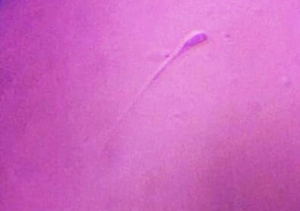 | a)  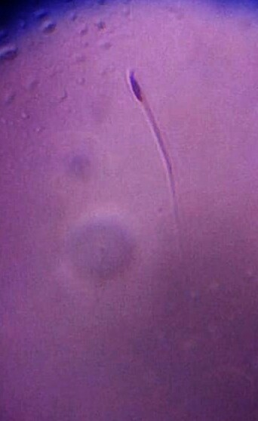
d)  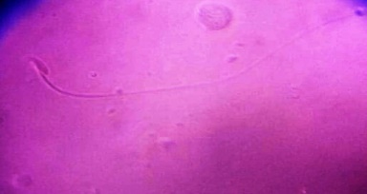 | c)  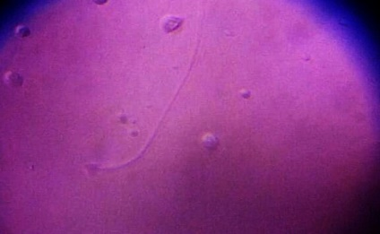
e)
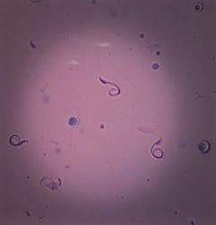

Figure 4:- A) normal sperm. B) without a hook. C) Amorphous.
- Hummer. E) Coiled tail.

The mean values of total sperm abnormalites in mice were represented in table (3) and figure (3). These data show that there was no significant difference between the control group and the Shark liver oil treated group as the mean values were (49.6$±21.82)$and(69.4$±25.27)$. There was also a significant increase in the total sperm abnormalities in the mean values of Taxotere treated group over the mean value of the control group and Shark liver oil only treated group where the mean values of them were ((972.2$±38.48)$vs (49.6$±21.82)$and (69.4$±25.27)$). Using Shark liver oil as a treatment after Taxotere dose injection showing a significant decrease in total sperm abnormalities comparing with taxotere treated group with mean values were ((91.4$±34.75)$vs (972.2$±38.48)$). Also, the protective effect of Slo injection before Taxotere treatment showing a significant decrease in total sperm abnormalities comparing with the taxotere treated group as the mean values were ((384.8$±49.71)$vs (972.2$±38.48)$). And the injection of Taxotere with Slo also showing a significant decrease in total sperm abnormalities comparing with taxotere treated group as the mean values were ((122$±37.77)$vs (972.2$±38.48)$). The results also show that using Slo as a treatment after Taxotere treatment was more efficient than its protective effect and than the injection of both SLO and Taxotere at the same time in decreasing the total sperm abnormalities.

DISCUSSION:-
The aim of this study evaluating the protective and treated effects of shark liver oil as natural products against the side effects of Taxotere on the chromosome, sperm. The results of our study showed that Taxotere as an anticancer drug causes cytogenetic effects including chromosome deletion, ring, centric attenuation, monosomy, and polyploidy. These results are consistent with as taxanes affect microtubules, it might be expected that they would induce numerical chromosome aberrations (aneuploidy) (Cunha, 2001). Docetaxel ( Taxotere) induced polyploid cells to undergo mitotic slippage and eventually spawn mononucleated cells via asymmetric cell division or neosis (Mittal et al.,2017).
Docetaxel -resistant human breast cancer cell lines (MCF-7 and MDA-MB-231) were created, and comparative genomic hybridization was used to identify genomic regions associated with resistance to docetaxel. MCF-7 resistant cells showed amplification of chromosomes 7, 17 and 18, and the deletion in chromosomes 6, 10, and 12. MDA-MB-231 resistant cells showed a gain of chromosomes 5, and 9, and loss of chromosomes 4, 8,10, 11, 12and 18. (Mcdonald et al., 2005).
Also, Taxotere caused head abnormalities of mice sperms like without hook and hammer shape head and also caused tail abnormalities in sperm like a coiled tail. These results agree with (Sariözkan et al., 2016) who observed that Taxotere as chemotherapeutic agent leads to damage in the reproductive system. Reproductive organs, especially testes, are the target organs for the damage resulting from chemotherapeutic agents. The testis produces mature gametes through spermatogenesis which is negatively affected when exposed to chemotherapeutic agents. Also, it was found that Docetaxel severely repressed spermatogenesis and sperm motility, and dramatically increased sperm abnormality in mice (Zhang et al.,2014).
All our results showed how efficient the shark liver oil is acting as a treatment against the side effect of Taxotere. The natural ether-lipids 1-O-alkylglycerols from shark liver oil improve boar sperm motility and fertility. The natural ether-lipids 1-O-alkylglycerols have multiple in vitro and in vivo properties: they reduce the side effects of radiotherapy, inhibit tumor growth and both stimulate and modulate immune responses (Mitre et al., 2004). Different mechanisms are suggested for these multiple activities, resulting from the incorporation of 1-O-alkylglycerols into membrane phospholipids, and lipid signaling interactions (Deniau et al., 2010).
Conclusion:-
Taxotere causes structural and numerical chromosomal aberration as shown in results. Deletion, centromeric attenuation, and ring, monoploidy and polyploid were detected. It also causes sperm’s head abnormalities to include without hook, amorphous and hummer head. The sperm’s tail abnormalities include sperms with coiled tails. It is so efficient to use shark liver oil as a treatment against the side effect of Taxotere.

REFERENCES:-
Cunha, K. S. (2001). Taxanes: the genetic toxicity of paclitaxel and docetaxel in somatic cells of Drosophila melanogaster.Mutagenesis,16(1), 79–84.

Deniau, A. L.; Mosset, P.; Pédrono, F.; Mitre, R.; Le Bot, D. and Legrand, A. B. (2010). Multiple beneficial health effects of natural alkylglycerols from shark liver oil. Marine Drugs, 8(7), 2175–2184.
Evaluation, D. (2015). Docetaxel labeling.

Green, B.S. (2009). Understanding the One-Way Anova. 3(2), 12.

Gupta, P.; Singhal, K.; Jangra, A. K.; Nautiyal, V. and Pandey, A. (2015).REVIEW ARTICLE SHARK LIVER OIL.
Hajimoradi, M.; Mohammad, Z.; Akbar, A.; Daneshmandi, S. and Pakravan, N. (2009).The effect of shark liver oil on the tumor infiltrating lymphocytes and cytokine pattern in mice. Journal of Ethnopharmacology 126, 565–570.

Hassett, G.; Harnett, P. and Manolios, N. (2001). Scleroderma in association with the use of docetaxel (taxotere) for breast cancer. Clinical and Experimental Rheumatology, 19(2), 197–200.

Herbst, R. S. and Khuri, F. R. (2003). Mode of action of docetaxel - A basis for combination with novel anticancer agents.Cancer Treatment Reviews, 29(5), 407–415.
Hotchkiss, K. A.; Ashton, A. W.; Mahmood, R.; Russell, R. G.; Sparano, J. A. and Schwartz, E. L. (2002).Inhibition of Endothelial Cell Function in Vitro and Angiogenesis in Vivo by Docetaxel ( Taxotere ): Association with Impaired Repositioning of the Microtubule Organizing Center . Mol Cancer Ther, 1(November), 1191–1200.

Kraus, L. A.; Samuel, S. K.; Schmid, S. M.; Dykes, D. J.; Waud, W. R. and Bissery, M. C. (2003).The mechanism of action docetaxel (Taxotere®) in xenograft models is not limited to bcl-2 phosphorylation. Investigational New Drugs, 21(3), 259– 268.
Mcdonald, S. L.; Stevenson, D. A. J.; Moir, S. E.; Hutcheon, A. W.; Haites, N. E.; Heys, S. D. and Schofield, A. C. (2005). Genomic changes identified by comparative genomic hybridisation in docetaxel-resistant breast cancer cell lines. European Journal of Cancer, 41, 1086–1094.
Mitre, R.; Cheminade, C.; Allaume, P.; Legrand, P. and Legrand, A. B. (2004). Oral intake of shark liver oil modifies lipid composition and improves motility and velocity of boar sperm. Theriogenology, 62(8), 1557–1566.

Mittal, K.; Donthamsetty, S.; Kaur, R.; Yang, C. and Gupta, M. V. (2017). Multinucleated polyploidy drives resistance to Docetaxel chemotherapy in prostate cancer. British journal of cancer, 116(9): 1186–1194.
Mukherjee, A.; Giri, A. K.; Sharma, A. and Talukder, G. (1988). Relative efficacy of short-term tests in detecting genotoxic effects of cadmium chloride in mice in vivo. Mutation Research/Genetic Toxicology, 206(2), 285–295.
Noguchi, S. (2006). Predictive factors for response to docetaxel in human breast cancers. Cancer Science, 97(9), 813–820.

Sariözkan, S.; Türk, G.; Güvenç, M.; Yüce, A.; Cantürk, F. and Yay, A. H. (2016). Effects of cinnamon ( C . zeylanicum ) bark oil against taxanes-induced damages in sperm quality , testicular and epididymal oxidant / antioxidant balance , testicular apoptosis , and sperm DNA integrity. Nutrition and Cancer, 68(3): 481-494.
Yonemura, Y.; Endou, Y.; Bando, E.; Kuno, K.; Kawamura, T.; Kimura, M.; Shimadac, T.; Miyamotoc K.; Sasakib T. and Sugarbaker, P. H. (2004). Effect of intraperitoneal administration of docetaxel on peritoneal dissemination of gastric cancer. Cancer Letters, 210(2), 189–196.
Zhang, L.; Yang, Y.; Song, Y. and Yang, H. (2014). Nanoparticle Delivery Systems Reduce the Reproductive Toxicity of Docetaxel in Rodents. Nano LIFE, 4(4), 1–11.
Zowail, M. E. M.; Osman, G. Y.; Mohamed, A. H. and El-Esawy, H. M. I. (2012). Protective Role of Lactobacillus Sporogenes ( Probiotic ) on Chrom Osom Al Ab Errat Ions and Dna Fr Agm Ent Ation in Schistosoma Mansoni Infected M Ice. The Egyptian Society of Experimental Biology, 8(1), 121–130.

